North Penn School District
Elementary Math Parent Letter
Grade 4
Unit 6 – Chapter 13: Algebra: Perimeter and Area
Examples for each lesson:
Lesson 13.1
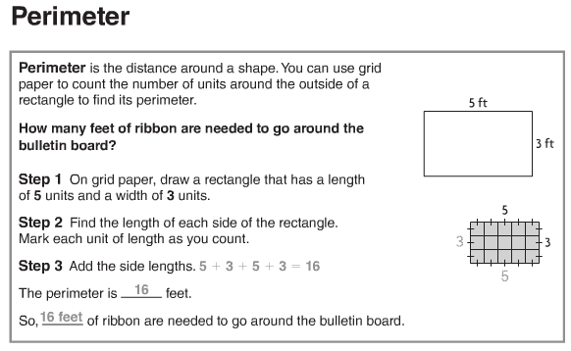
More information on this strategy is available on Animated Math Model #54.

Lesson 13.2
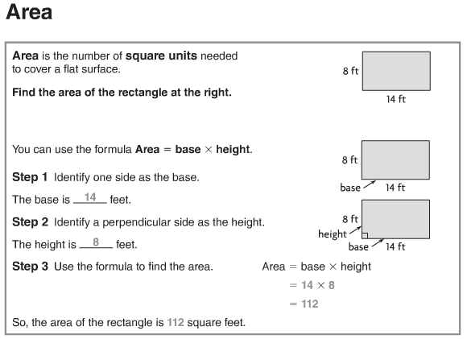
More information on this strategy is available on Animated Math Models #55, 56, 57.
Lesson 13.3
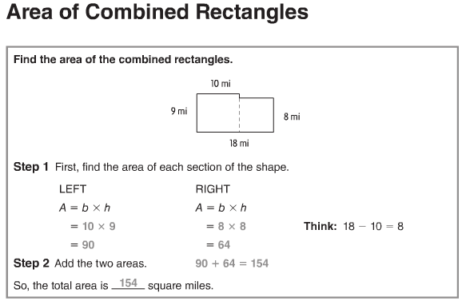
More information on this strategy is available on Animated Math Model #58.

Lesson 13.4
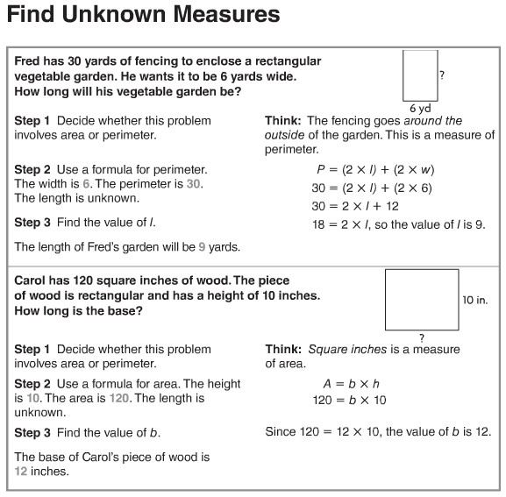

Lesson 13.5
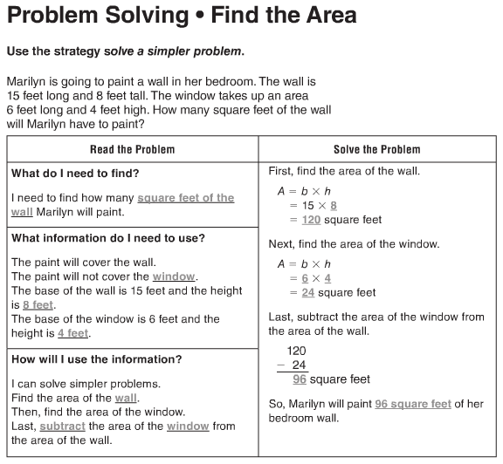
Vocabulary
Area – the number of square units needed to cover a flat surface
Base – any side of a two-dimensional figure
Formula – a set of symbols that expresses a mathematical rule
Height – the measure of a perpendicular from the base to the top of a two-dimensional figure
Perimeter – the distance around a figure
Square unit – a unit of area, with dimensions of 1 unit x 1 unit

