North Penn School District
Elementary Math Parent Letter
Grade 4
Unit 6 – Chapter 12: Relative Sizes of Measurement Units
Examples for each lesson:
Lesson 12.1
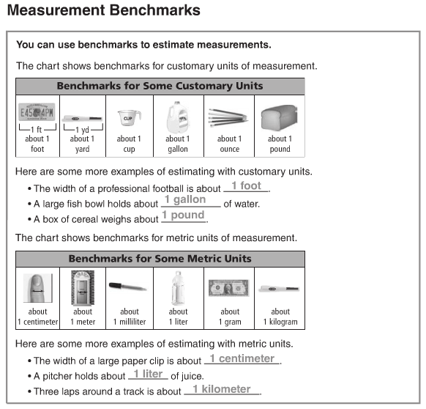

Lesson 12.2
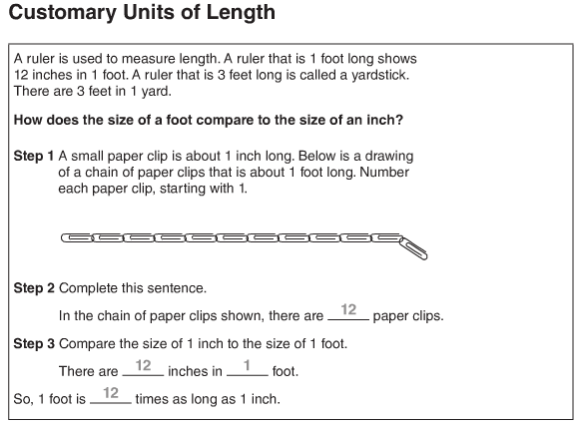
More information on this strategy is available on Animated Math Model #45.
Lesson 12.3
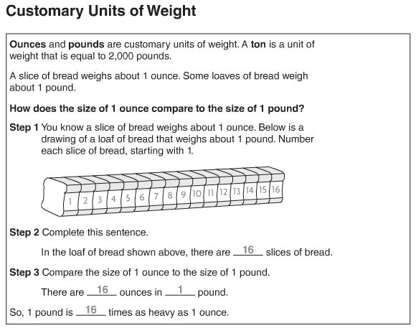
More information on this strategy is available on Animated Math Model #46.
Lesson 12.4
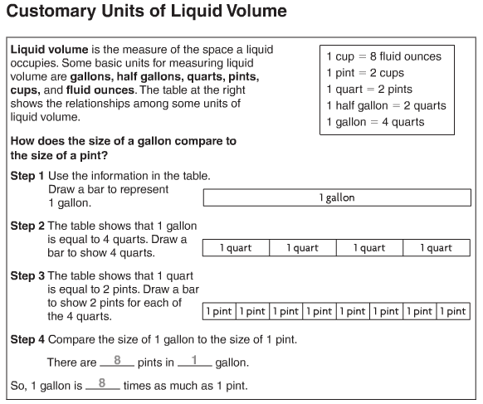
More information on this strategy is available on Animated Math Model #47.

Lesson 12.5
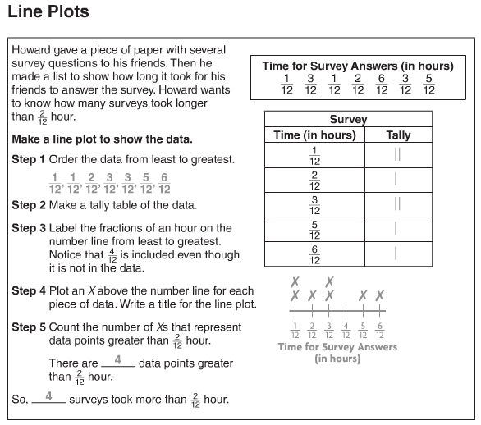

Lesson 12.6
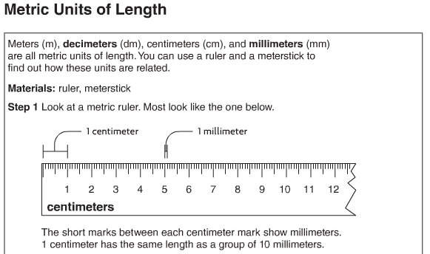
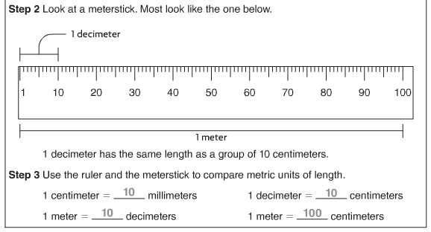
More information on this strategy is available on Animated Math Models #48, 49.

Lesson 12.7
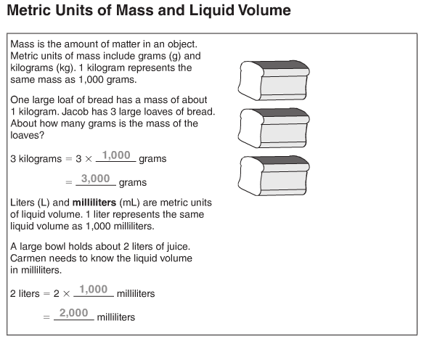
More information on this strategy is available on Animated Math Models #50, 51.

Lesson 12.8
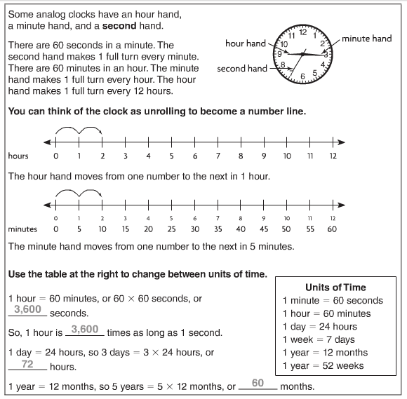
More information on this strategy is available on Animated Math Model #52.
Lesson 12.9
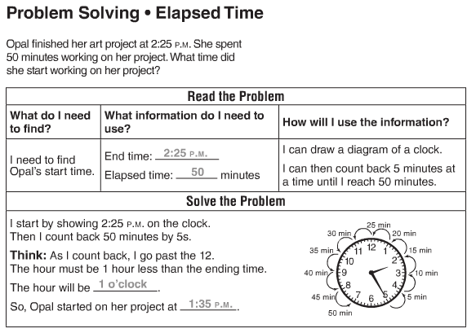
More information on this strategy is available on Animated Math Model #53.
Lesson 12.10
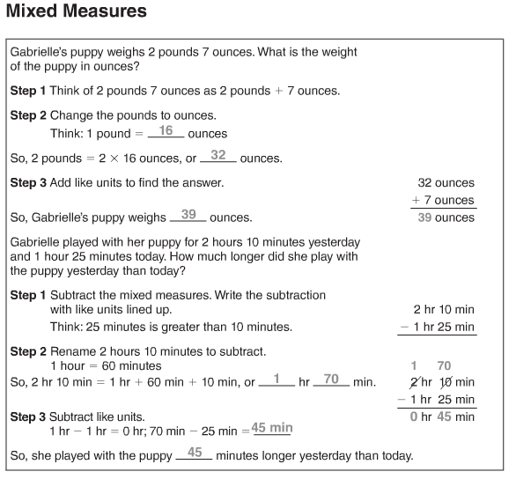
Lesson 12.11
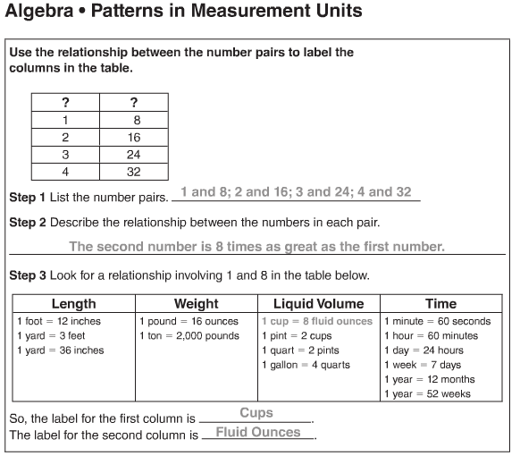
Vocabulary
Cup – a customary unit used to measure a liquid volume
Decimeter – a metric unit for measuring length or distance
Fluid ounce – the smallest customary unit for measuring liquid volume
Gallon – a customary unit used to measure liquid volume
Half gallon – a customary unit used to measure liquid volume
Line plot – a graph that shows the frequency of data along a number line
Milliliter – a metric unit used to measure liquid volume
Millimeter – a metric unit used to measure length
Ounce – a customary unit used to measure weight
Pint – a customary unit used to measure liquid volume
Pound – a customary unit used to measure weight
Quart – a customary unit used to measure liquid volume
Second – a small unit of time
Ton -- a customary unit used to measure weight

