North Penn School District
Elementary Math Parent Letter
Grade 4
Unit 5 – Chapter 11: Angles
Examples for each lesson:
Lesson 11.1
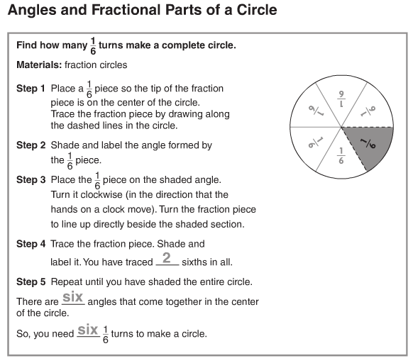

Lesson 11.2
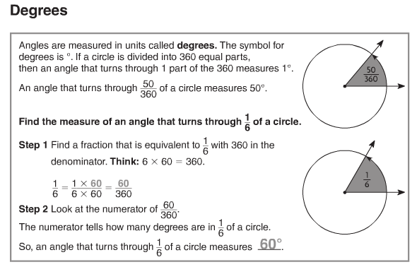
Lesson 11.3
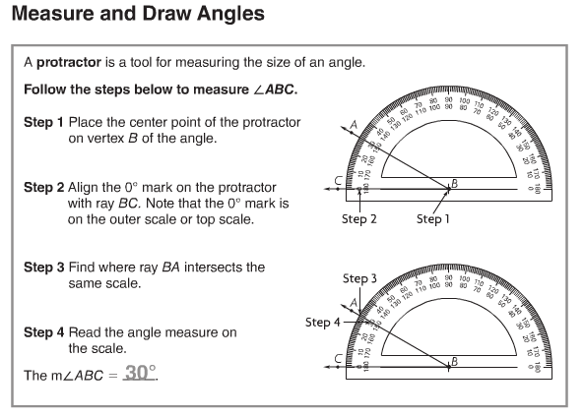
More information on this strategy is available on Animated Math Model #44.
Lesson 11.4
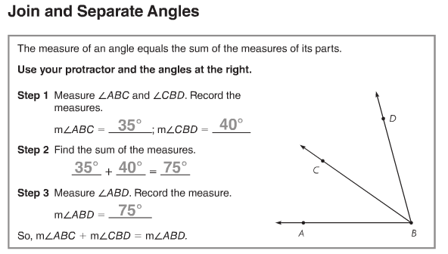
Lesson 11.5
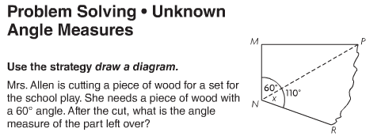
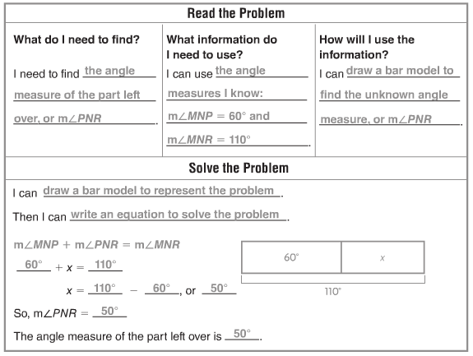
Vocabulary
Clockwise – in the same direction in which the hands of a clock move
Counterclockwise – in the opposite direction in which the hands of a clock move
Degree (°) – the unit used for measuring angles
Protractor – a tool used for measuring the size of an angle
Acute angle – an angle that measure greater than 0° and less than 90°
Obtuse angle – an angle that measures greater than 90° and less than 180°
Ray – a part of a line; it has one endpoint and continues without end in one direction
Right angle – an angle that forms a square corner and has a measure of 90°
Vertex – the point at which two rays on an angle meet or two (or more) line segments meet in a two-dimensional shape

