North Penn School District
Elementary Math Parent Letter
Grade 4
Unit 5 – Chapter 10: Two-Dimensional Figures
Examples for each lesson:
Lesson 10.1
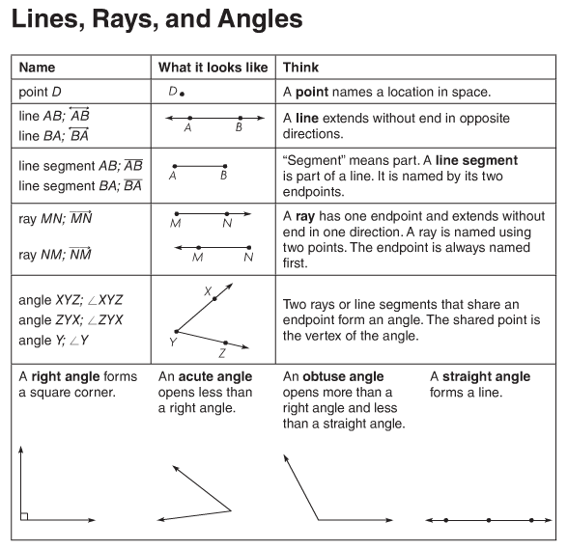
More information on this strategy is available on Animated Math Models #38, 39.

Lesson 10.2
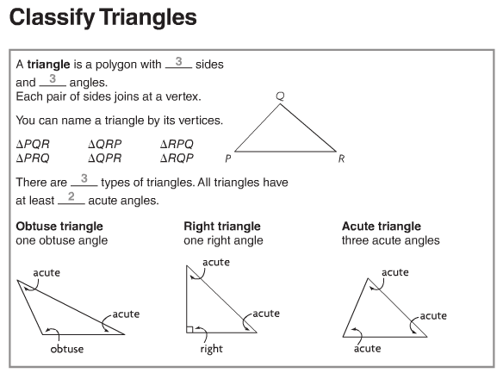
Lesson 10.3
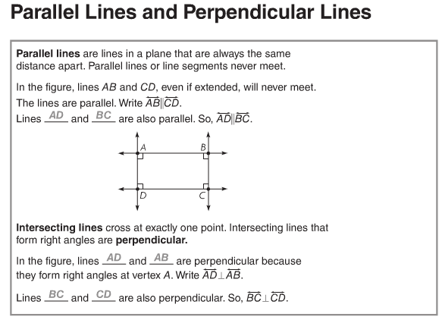
More information on this strategy is available on Animated Math Model #40.

Lesson 10.4
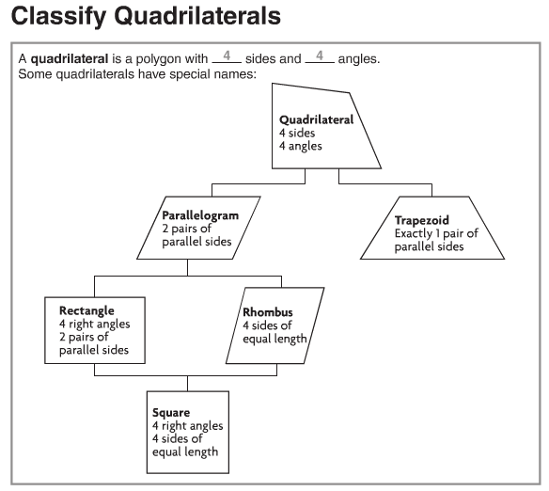
More information on this strategy is available on Animated Math Model # 41.
Lesson 10.5
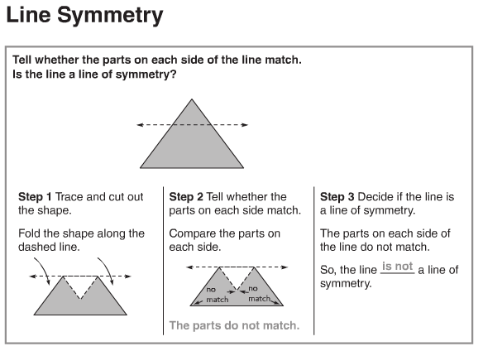
More information on this strategy is available on Animated Math Model # 42.
Lesson 10.6
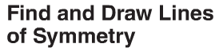
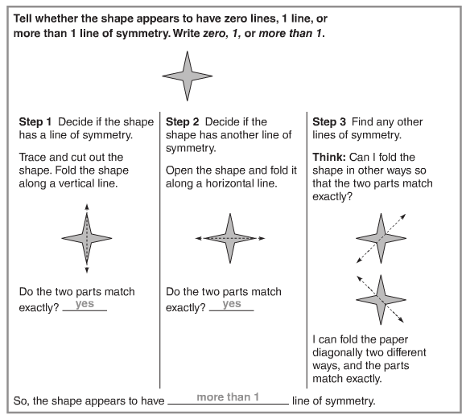
More information on this strategy is available on Animated Math Model # 42.

Lesson 10.7
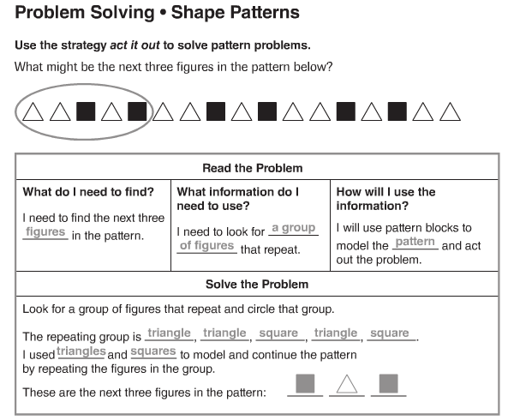
More information on this strategy is available on Animated Math Model # 43.
Vocabulary
Acute angle – an angle that has a measure less than a right angle
Line – a straight path of points that continues without end in both directions
Line of symmetry – an imaginary line that divides a shape into two congruent parts
Line symmetry – what a shape has if it can be folded about a line so that its two parts match exactly
Obtuse angle – an angle that has a measure greater than a right angle
Ray – a part of a line, with one endpoint, that is straight and continues in one direction
Right angle – an angle that forms a square corner and has a measure of 90°
Straight angle – an angle in which two rays point in opposite directions so that they form a line

