North Penn School District
Elementary Math Parent Letter
Grade 4
Unit 4 – Chapter 9: Relate Fractions and Decimals
Examples for each lesson:
Lesson 9.1
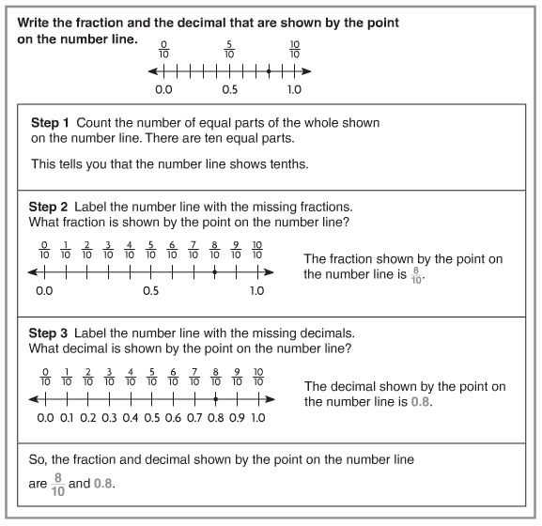
More information on this strategy is available on Animated Math Model #34.

Lesson 9.2
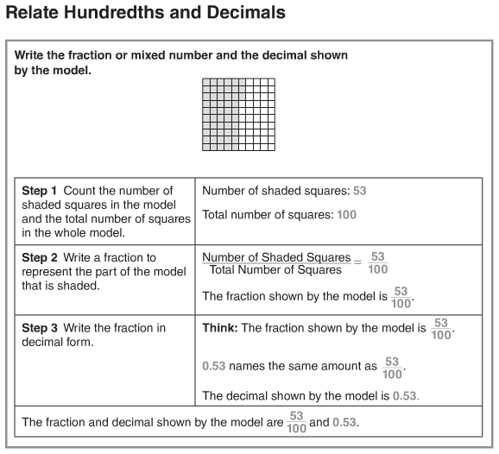
More information on this strategy is available on Animated Math Model #35.
Lesson 9.3
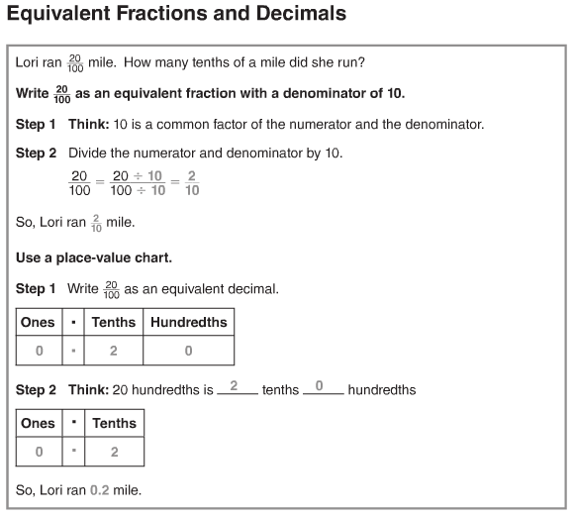
More information on this strategy is available on Animated Math Model #36.
Lesson 9.4
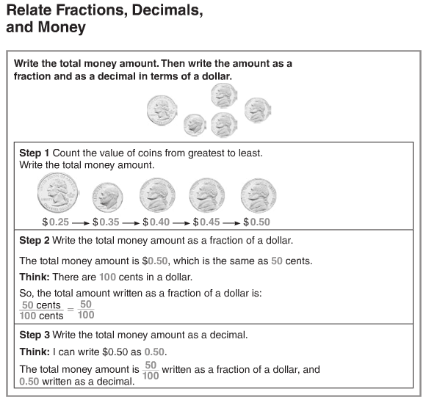
More information on this strategy is available on Animated Math Model # 37.

Lesson 9.5
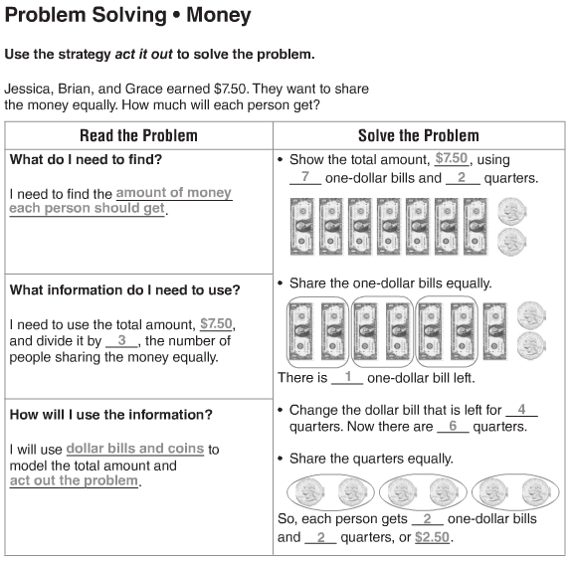

Lesson 9.6
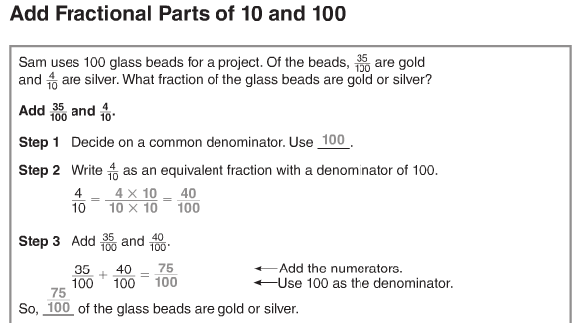
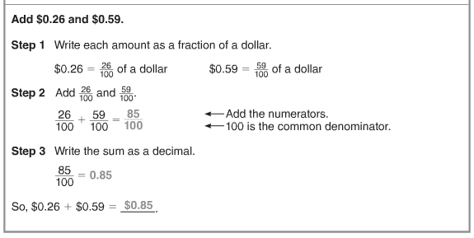

Lesson 9.7
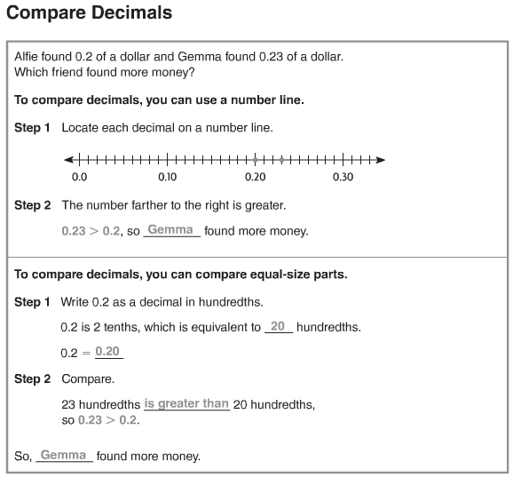
Vocabulary
Decimal – a number with one or more digits to the right of the decimal point
Decimal point – a symbol used to separate dollars from cents in a money amount and to separate the ones and the tenths place in a decimal
Equivalent decimals – two or more decimals that name the same amount
Hundredth – one of one hundred equal parts
Tenth – one of ten equal parts
Equivalent fractions – two or more fractions that name the same amount
Fraction – a number that names part of a whole or part of a group
Compare – to describe whether numbers are equal to, less than, or greater than each other

