North Penn School District
Elementary Math Parent Letter
Grade 4
Unit 4 – Chapter 8: Multiply Fractions by Whole Numbers
Examples for each lesson:
Lesson 8.1
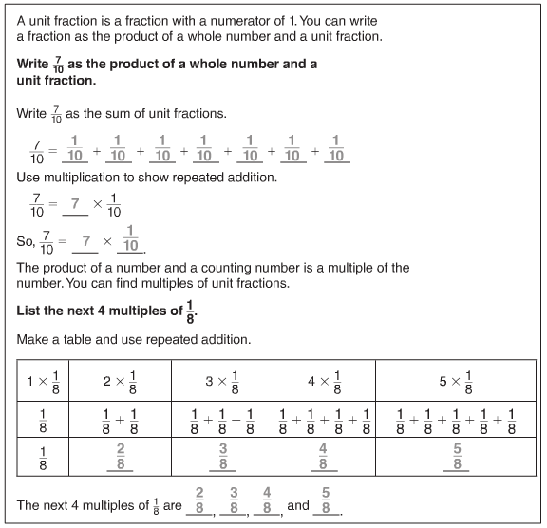

Lesson 8.2
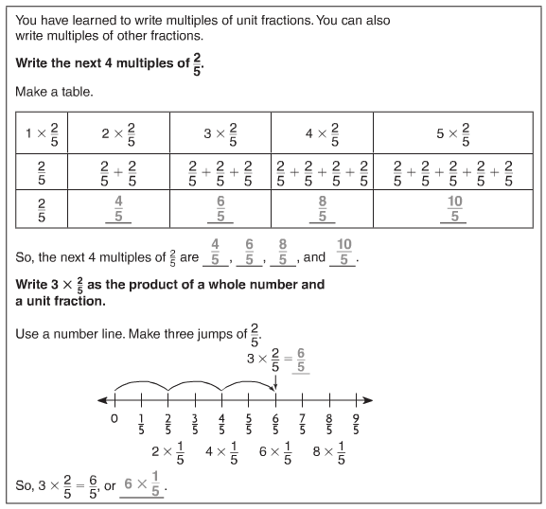
Lesson 8.3
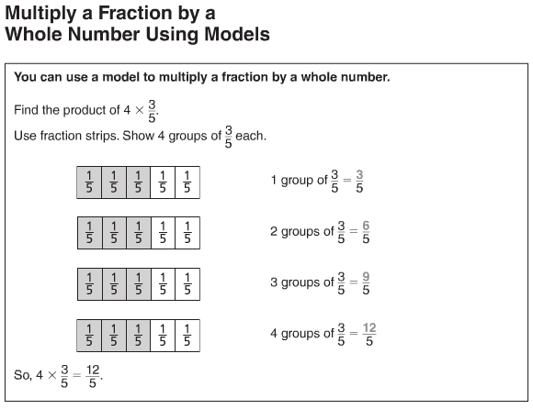
More information on this strategy is available on Animated Math Model #33.
Lesson 8.4
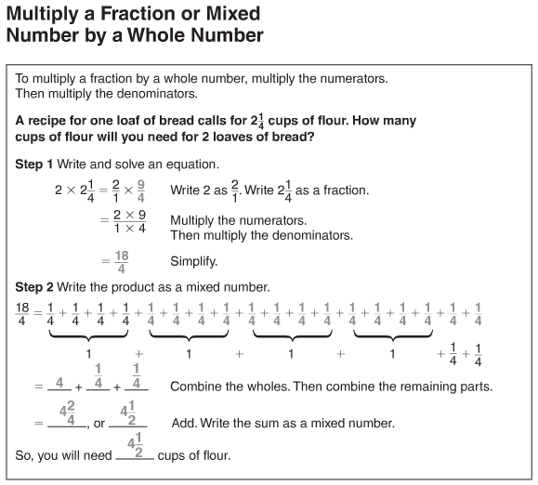
More information on this strategy is available on Animated Math Models #30, 33.

Lesson 8.5
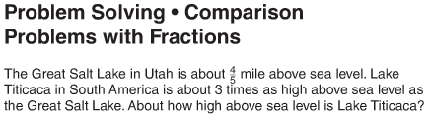
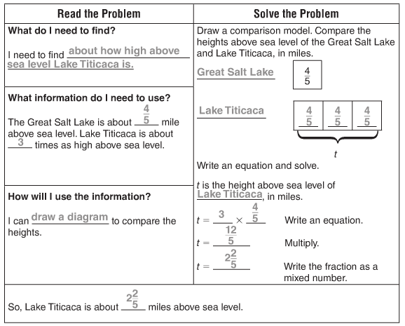
More information on this strategy is available on Animated Math Models #30, 33.
Vocabulary
Factor – a number that is multiplied by another number to find a product
Fraction – a number that names part of a whole or part of a group
Identity Property of Multiplication – the property that states the product of any number and 1 is that number
Multiple – the product of two counting numbers
Product – the answer to a multiplication problem
Unit fraction – a fraction that has a numerator of one

