North Penn School District
Elementary Math Parent Letter
Grade 4
Unit 3 – Chapter 7: Add and Subtract Fractions
Examples for each lesson:
Lesson 7.1
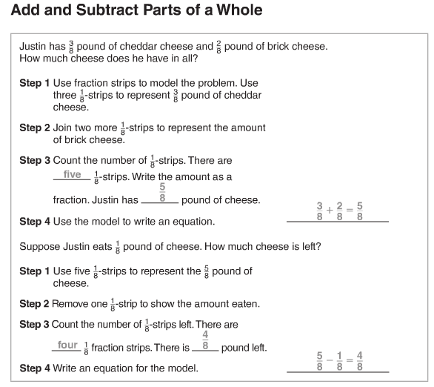

Lesson 7.2
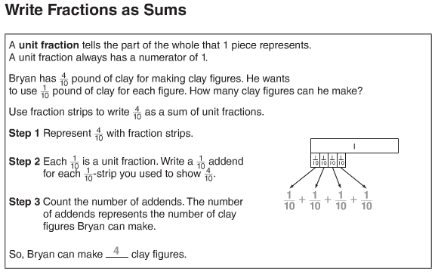

Lesson 7.3
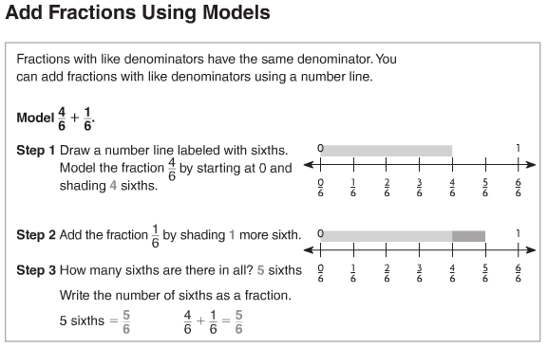
More information on this strategy is available on Animated Math Model #27.

Lesson 7.4
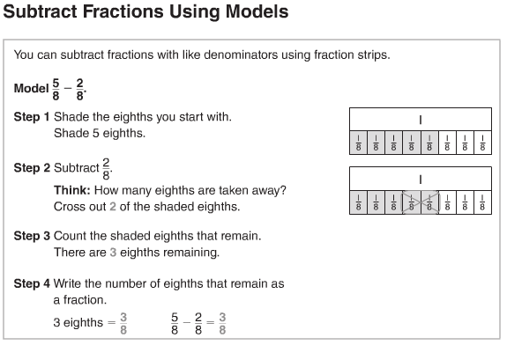
More information on this strategy is available on Animated Math Model #28.

Lesson 7.5
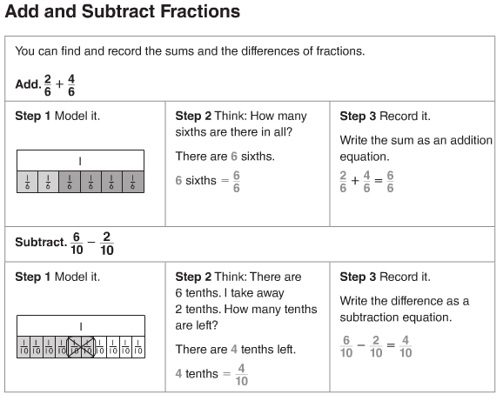
More information on this strategy is available on Animated Math Model #29.
Lesson 7.6
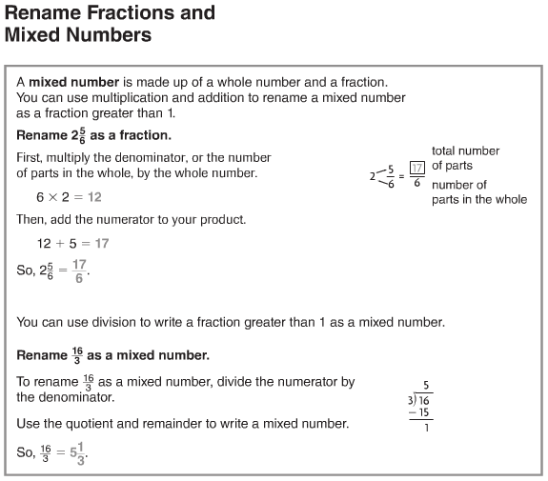
More information on this strategy is available on Animated Math Model #30.
Lesson 7.7
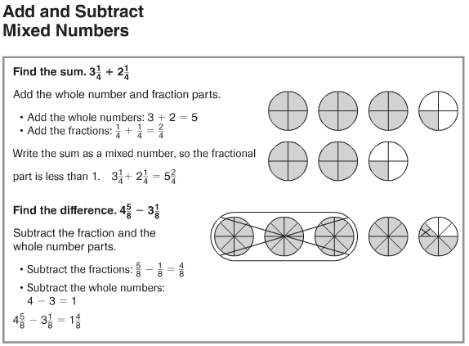
More information on this strategy is available on Animated Math Model #31.
Lesson 7.8
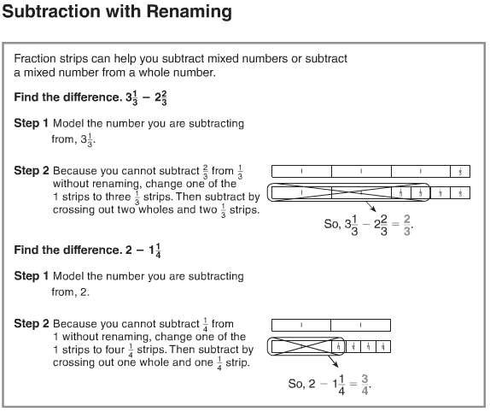
More information on this strategy is available on Animated Math Model #32.
Lesson 7.9
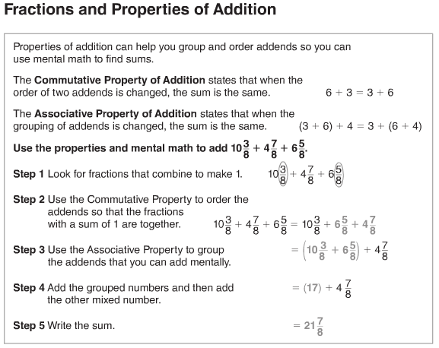
Lesson 7.10
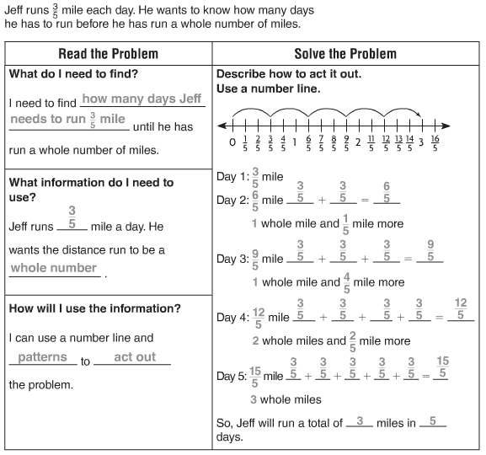
Vocabulary
Mixed number – an amount given as a whole number and a fraction
Unit fraction – a fraction that has a numerator of one
Associative Property of Addition – the property that states that when the grouping of addends is changed, the sum is the same
Commutative Property of Addition – the property that states that when the order of two or more addends is changed, the sum is the same
Denominator – the part of a fraction below the line, which tells how many equal parts there are in the whole group or in a group
Fraction – a number that names a part of a whole or part of a group
Numerator – the part of a fraction above the line, which tells how many parts are being counted
Simplest form – a fraction in which the numerator and the denominator have only 1 as a common factor

