North Penn School District
Elementary Math Parent Letter
Grade 4
Unit 3 – Chapter 6: Fraction Equivalence and Comparison
Examples for each lesson:
Lesson 6.1
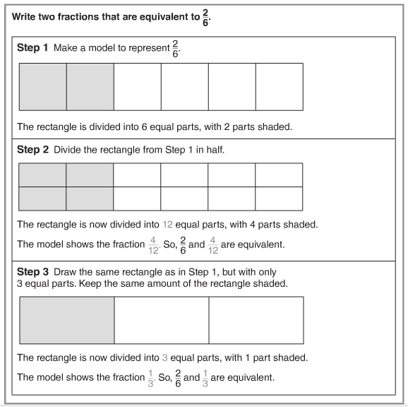

Lesson 6.2
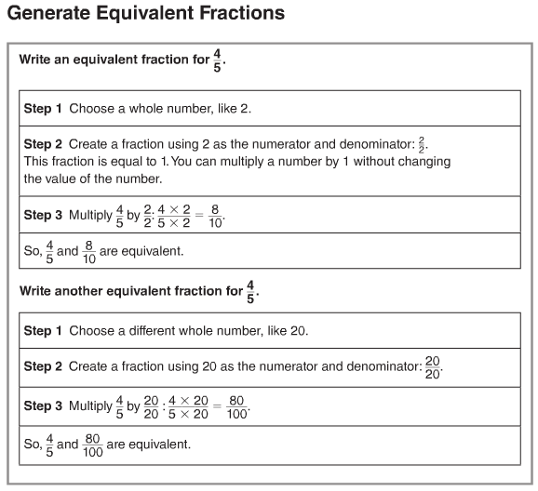
More information on this strategy is available on Animated Math Model #23.
Lesson 6.3
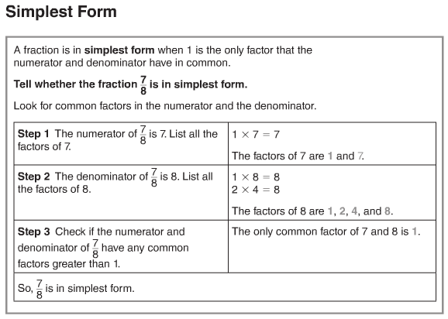
More information on this strategy is available on Animated Math Model #24.
Lesson 6.4
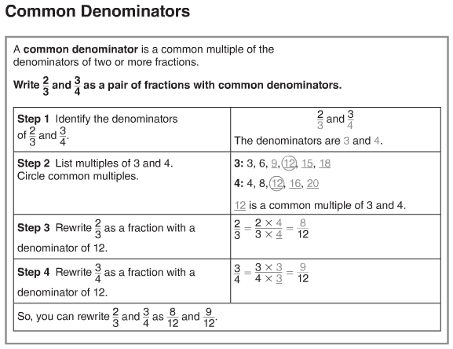
Lesson 6.5
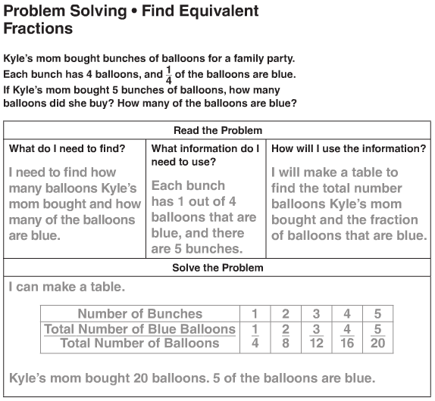
More information on this strategy is available on Animated Math Model #23.

Lesson 6.6
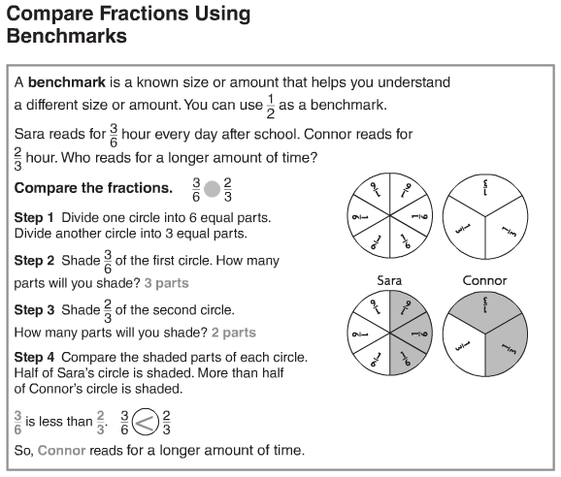
More information on this strategy is available on Animated Math Model #25.
Lesson 6.7
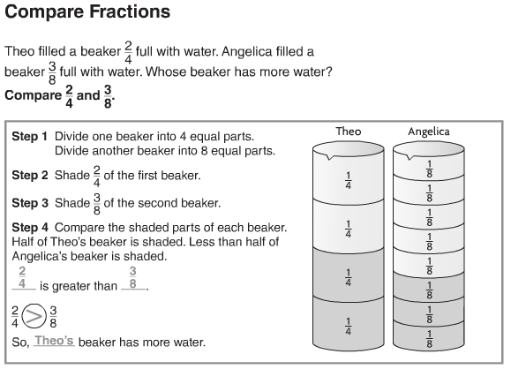
Lesson 6.8
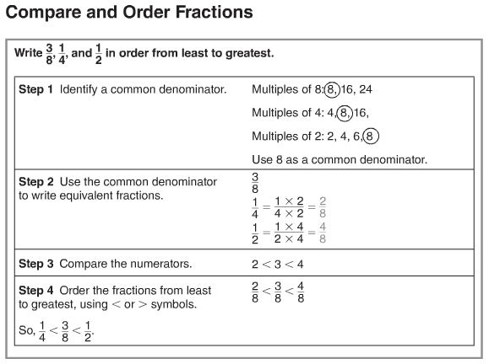
More information on this strategy is available on Animated Math Model #26.
Vocabulary
Benchmark – a known size or amount that helps you understand a different size or amount
Common denominator – a common multiple of two or more denominators
Equivalent fractions – two or more fractions that name the same amount
Simplest form – A fraction is in its simplest form if the numerator and denominator have only 1 as a common factor

