North Penn School District
Elementary Math Parent Letter
Grade 4
Unit 2 – Chapter 5: Factors, Multiples, and Patterns
Examples for each lesson:
Lesson 5.1
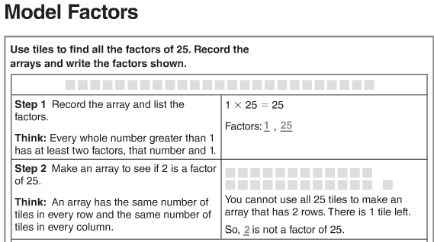
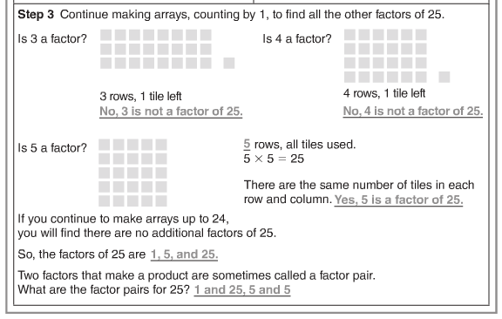
More information on this strategy is available on Animated Math Model #20.
Lesson 5.2
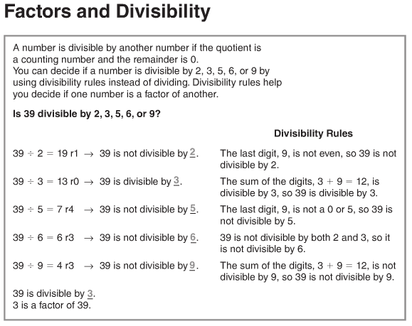
Lesson 5.3
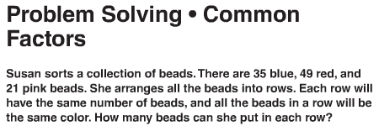
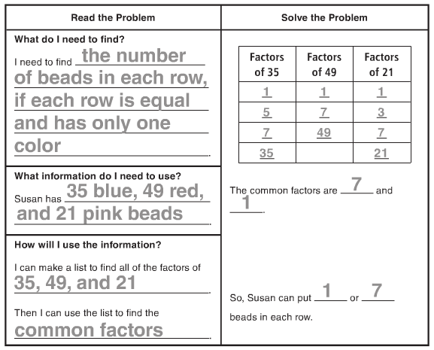
Lesson 5.4
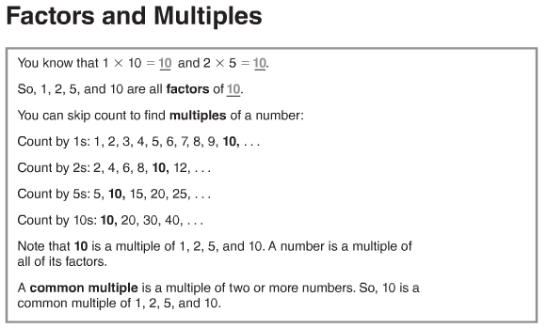
More information on this strategy is available on Animated Math Model #20.
Lesson 5.5
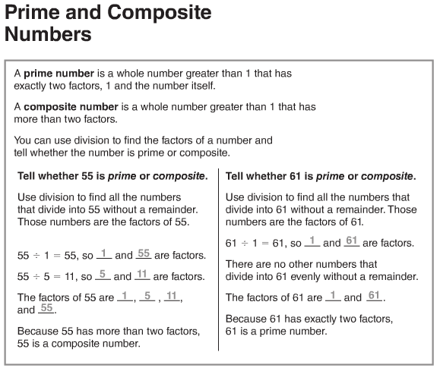
More information on this strategy is available on Animated Math Model #21.

Lesson 5.6
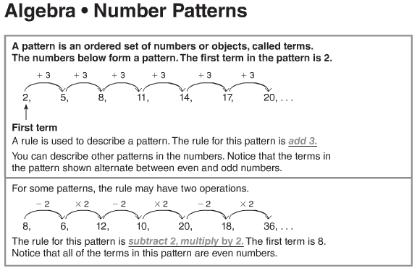
More information on this strategy is available on Animated Math Model #22.
Vocabulary
Common factor – a number that is a factor of two or more numbers
Common multiple – a number that is a multiple of two or more numbers
Composite number – a number that has more than two factors
Divisible – a number is divisible by another number if the quotient is a counting number and the remainder is zero
Factor – a number multiplied by another number to find a product
Pattern – an ordered set of numbers or objects
Prime number – a number that has exactly two factors, one and itself
Term – each number or object in a pattern

