North Penn School District
Elementary Math Parent Letter
Grade 4
Unit 2 – Chapter 4: Divide by 1-Digit Numbers
Examples for each lesson:
Lesson 4.1
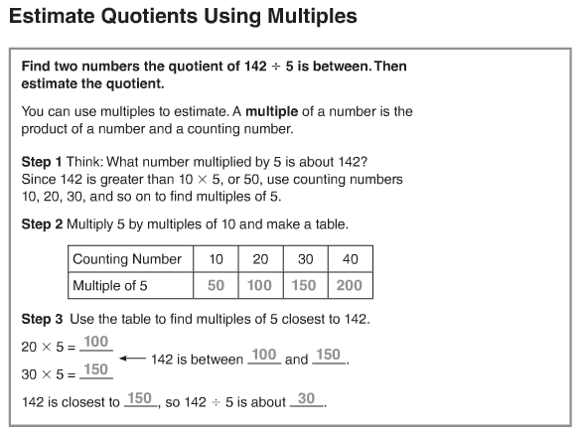

Lesson 4.2
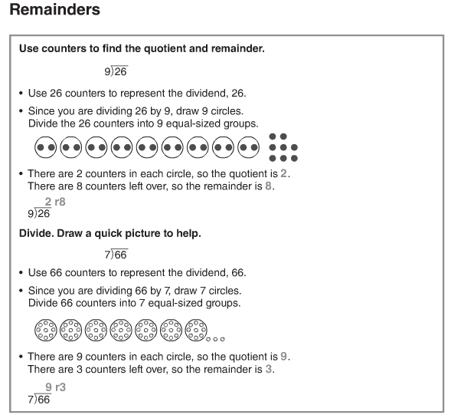
More information on this strategy is available on Animated Math Model #13.

Lesson 4.3
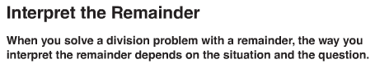
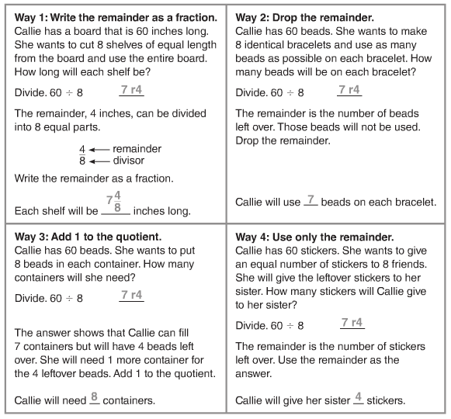

Lesson 4.4
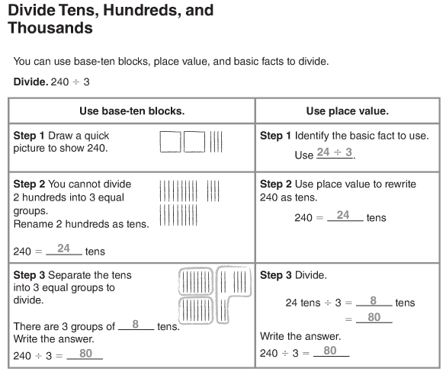
More information on this strategy is available on Animated Math Model #14.
Lesson 4.5
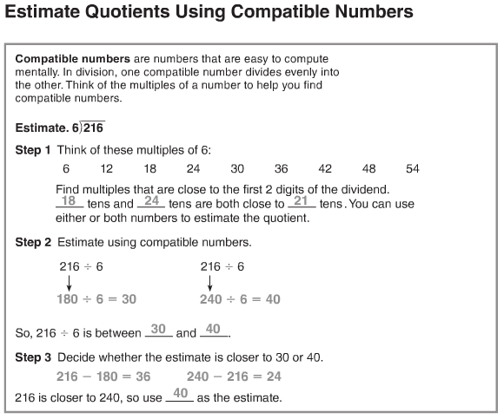
More information on this strategy is available on Animated Math Model #15.

Lesson 4.6
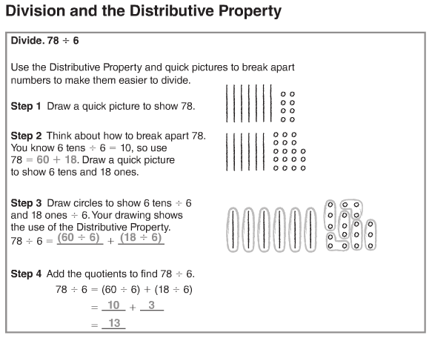
Lesson 4.7
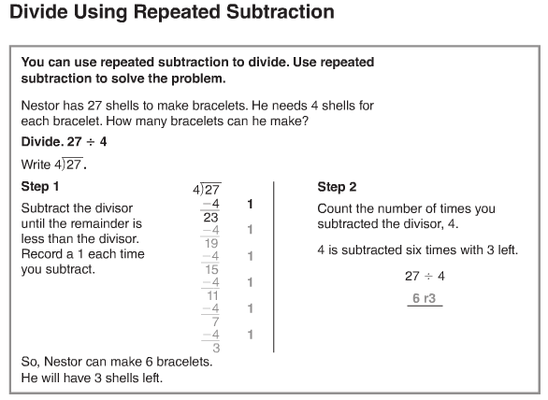
More information on this strategy is available on Animated Math Model #16.
Lesson 4.8
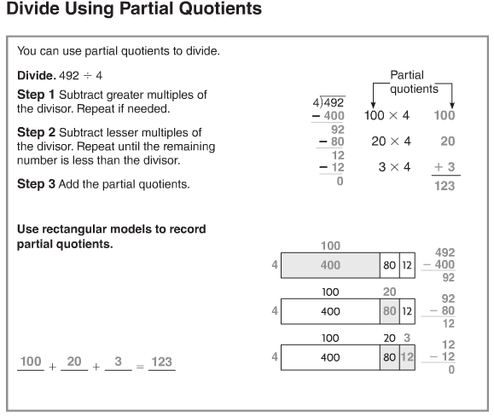

Lesson 4.9
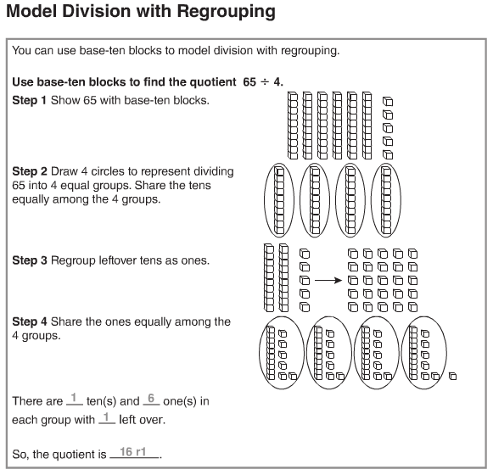

Lesson 4.10
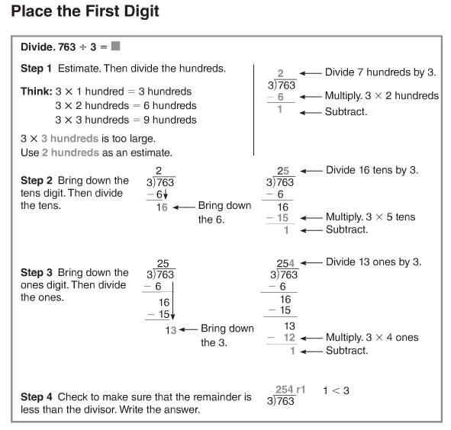
More information on this strategy is available on Animated Math Model #17.

Lesson 4.11
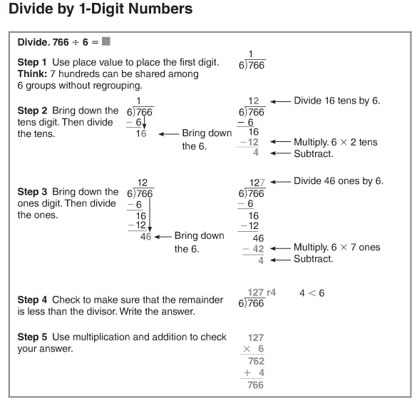
More information on this strategy is available on Animated Math Models #18, 19.

Lesson 4.12
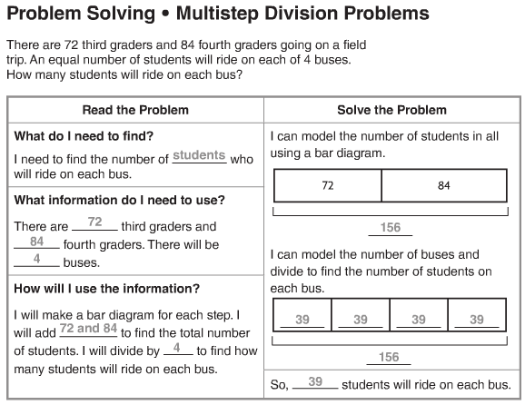
Vocabulary
Compatible numbers – numbers that are easy to compute with mentally
Multiple – a number that is the product of a given number and a counting number
Partial quotient – a method of dividing in which multiples of the divisor are subtracted from the dividend and then the quotients are added together
Remainder – the amount left over when a number cannot be divided equally
Dividend – the number that is to be divided in a division problem
Divisor – the number that divides the dividend

