North Penn School District
Elementary Math Parent Letter
Grade 4
Unit 1 – Chapter 3: Multiply by 2-Digit Numbers
Examples for each lesson:
Lesson 3.1
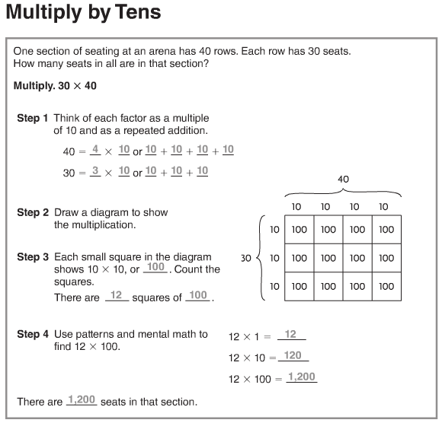

More information on this strategy is available on Animated Math Model #11.

Lesson 3.2
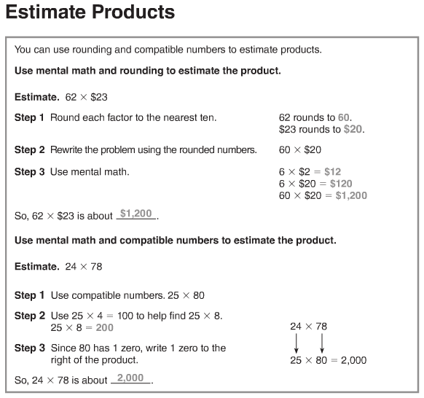
More information on this strategy is available on Animated Math Model #7.
Lesson 3.3
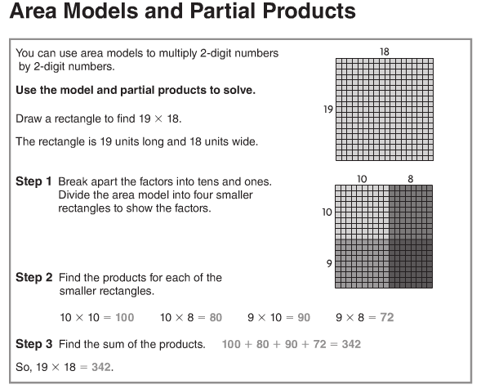
Lesson 3.4
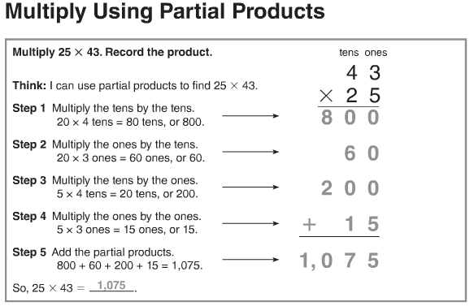
Lesson 3.5
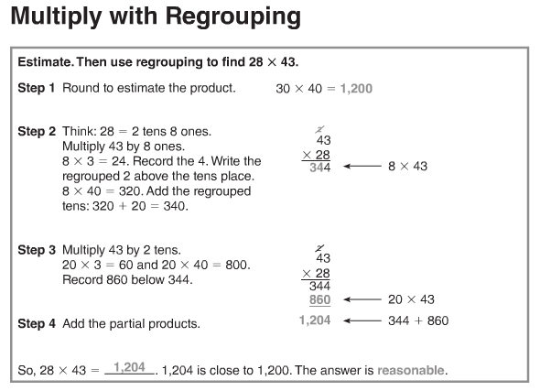
More information on this strategy is available on Animated Math Model #12.
Lesson 3.6
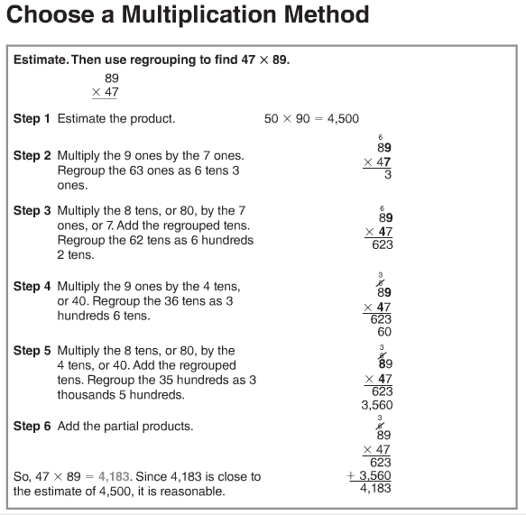

More information on this strategy is available on Animated Math Model #12.

Lesson 3.7
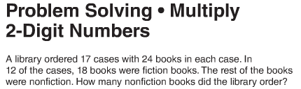
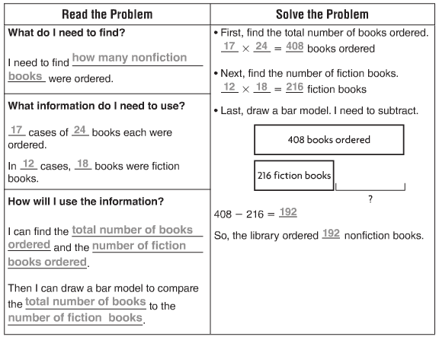
Vocabulary
Compatible numbers – numbers that are easy to compute with mentally
Associative Property of Multiplication – the property that states that when the grouping of factors is changed, the product remains the same
Commutative Property of Multiplication – the property that states when the order of two factors is changed, the product remains the same
Estimate – to find an answer that is close to the exact amount
Partial product – a method of multiplying in which the ones, tens, hundreds, and so on are multiplied separately and then the products are added together
Product – the answer in a multiplication problem
Regroup – to exchange amounts of equal value to rename a number

