North Penn School District
Elementary Math Parent Letter - Grade 4
Unit 1 – Chapter 2: Multiply by 1-Digit Numbers

Examples for each lesson:
Lesson 2.1
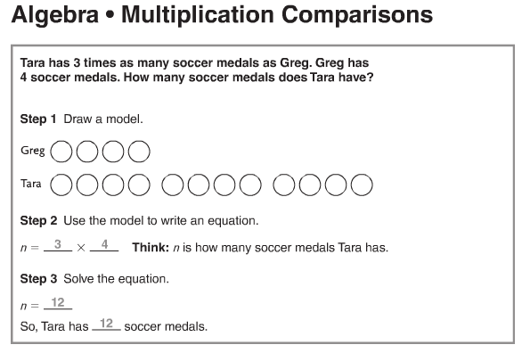

Lesson 2.2
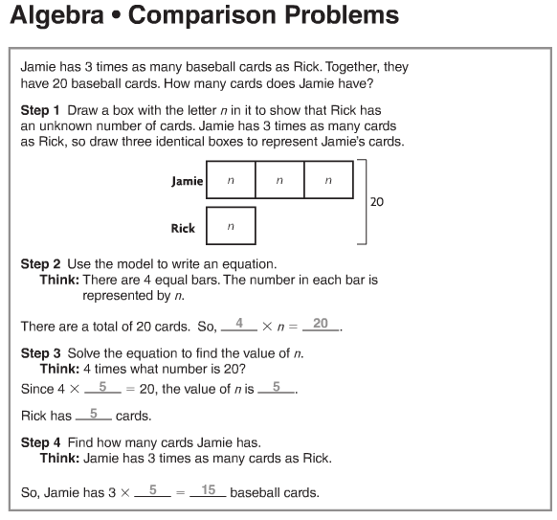
Lesson 2.3
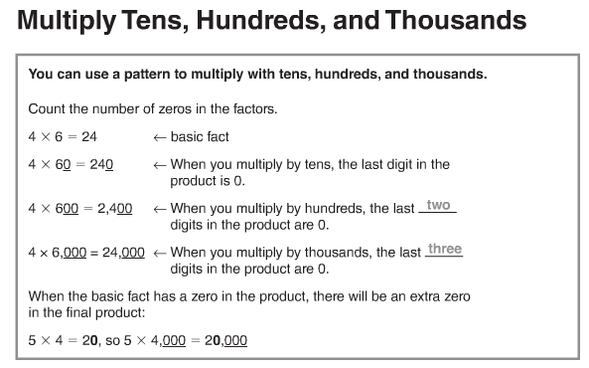
More information on this strategy is available on Animated Math Model #5.

Lesson 2.4
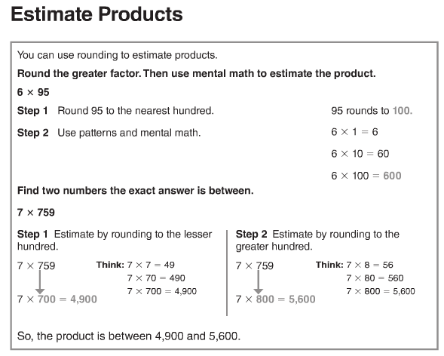
More information on this strategy is available on Animated Math Models #6, 7.
Lesson 2.5
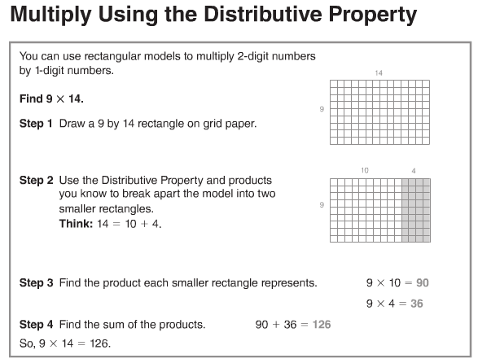
More information on this strategy is available on Animated Math Model #8.

Lesson 2.6
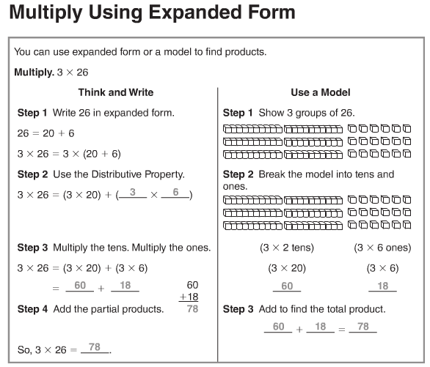
Lesson 2.7
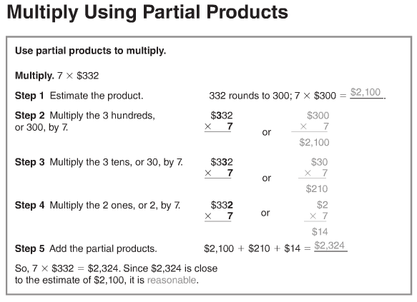

Lesson 2.8
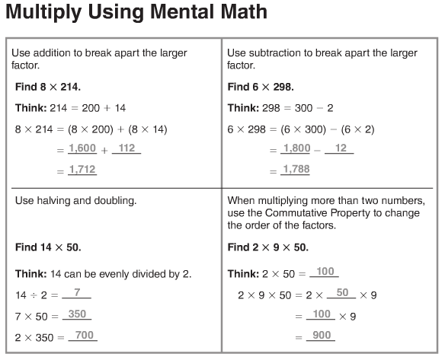
More information on this strategy is available on Animated Math Model #8.

Lesson 2.9
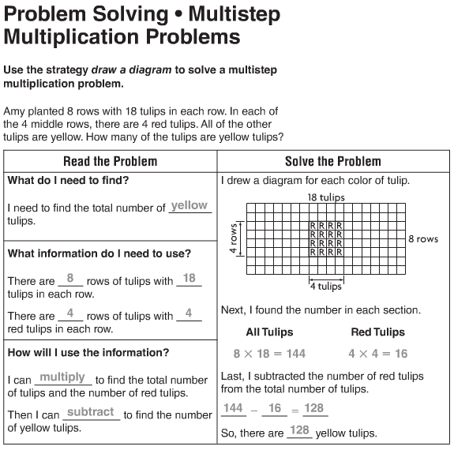

Lesson 2.10
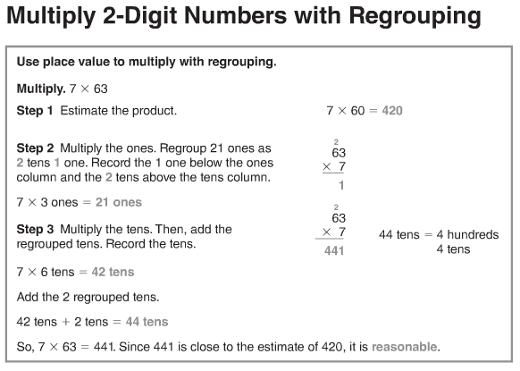
More information on this strategy is available on Animated Math Model #9.
Lesson 2.11
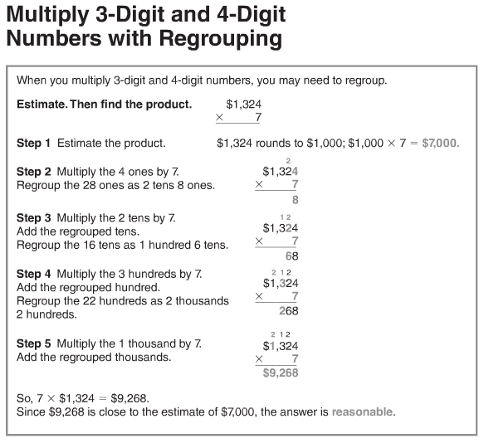
More information on this strategy is available on Animated Math Model #10
Lesson 2.12
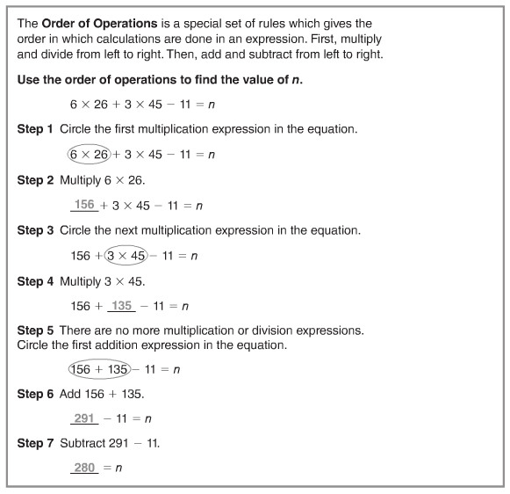

Vocabulary
Distributive Property – the property that states that
multiplying a sum by a number is the same as multiplying
each addend by the number and then adding the products
Partial product – a method of multiplying in which the ones,
tens, hundreds, and so on are multiplied separately and
then the products are added together
Estimate – to find an answer that is close to the exact amount

Expanded form – a way to write numbers by showing the value
of each digit
Factor – a number that is multiplied by another number to find
a product
Round – to replace a number with another number that tells
about how many or how much

