Chapter 1: Place Value, Addition and Subtraction to 1 Million
Study Guide
Lesson 1: Place Value
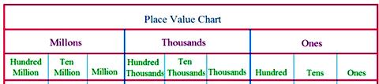

Lesson 2: Read and Write #s
Standard Form: 262,401
Word Form: two hundred sixty-two thousand, four hundred one
Expanded Form: 200,000 + 60,000 + 2,000 + 400 + 1

Lesson 3: Compare and Order #s
Step 1. Use the stacking strategy (write #s in a column, one under the other lining up place value columns)
Step 2. If it is the same # in same place value column, go to next largest place value column.
Step 3. Continue until the numbers differ. Circle this column.
Step 4. If they don’t differ, then they are =
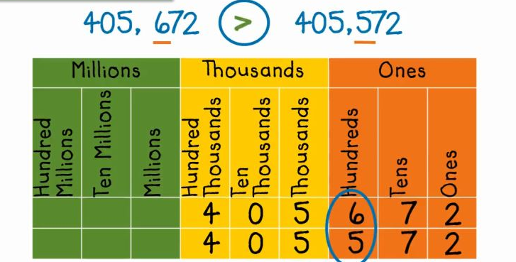
Lesson 4: Round #s
1. Circle the digit in the place value column to round.
2. Look at the # directly to the right. Underline it. If the underlined number is…
5 or more, add 1 more to circled #
4 or less, let it rest (circled # stays the same)
3. All digits to right of circled # become 0, the numbers to the left, just bring down (unless you had to regroup.
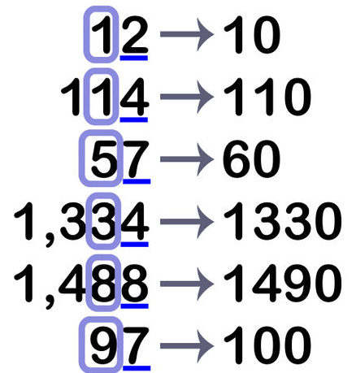

Lesson 5: Rename #s
Lesson 6: Add Whole #s
45, 698 + 5, 284 = ________
Step 1: Rewrite problem vertically (stacked) **Line up place value columns**
4 5, 6 9 8
+ 5, 2 8 4

Step 2: Start with smallest place value column, regrouping when necessary.
4 5, 6 9 8 4 5, 6 9 8
+ 5, 2 8 4 + 5, 2 8 4
2 5 0, 9 8 2

Lesson 7: Subtract Whole #s
7 9, 4 3 6 – 1 2, 9 2 7 = ________
Step 1: Rewrite problem vertically (stacked) **Line up place value columns**
7 9, 4 3 6
- 1 2, 9 2 7

Step 2: Start at smallest place value column, regrouping when necessary.
2 16 8 14 2 16
7 9, 4 3 6 7 9, 4 3 6
- 1 2, 9 2 7 - 1 2, 9 2 7
9 6 6, 5 0 9

Lesson 8: Problem Solving
CUBES: Circle important information. Underline question. Block key words/phrases. Evaluate using key words/phrases. Show work to solve. Write answer with label.

