Ch 2 Study Guide – 4th Grade
Lesson 1 – multiplication comparisons Lesson 2 – comparison problems
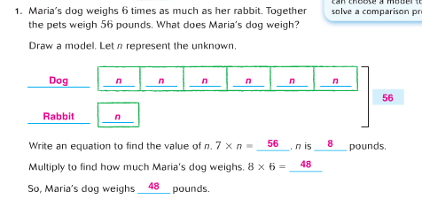
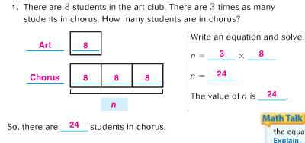

Lesson 3 – multiply 10s, 100s, 1000s Lesson 4 – estimate produc
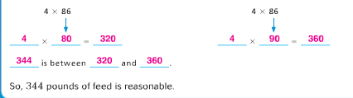
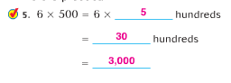

Lesson 5 – Multiply using the distributive property Lesson 6 – multiply using expanded form
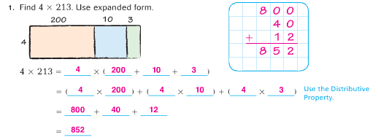
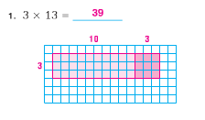

Lesson 7 – Multiply with partial products Lesson 8 – multiply with mental math
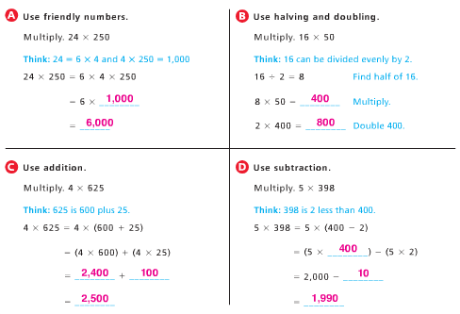
**SEE ATTACHED DIRECTIONS

Lesson 9 – Multi-step multiplication problems
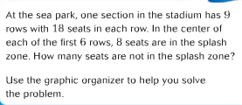
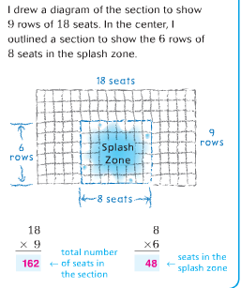

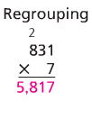
Lesson 10 and 11 – multiply 2-4 digit numbers
with regrouping

*Lesson 12 focuses on application of multiplication strategies in word problems.

